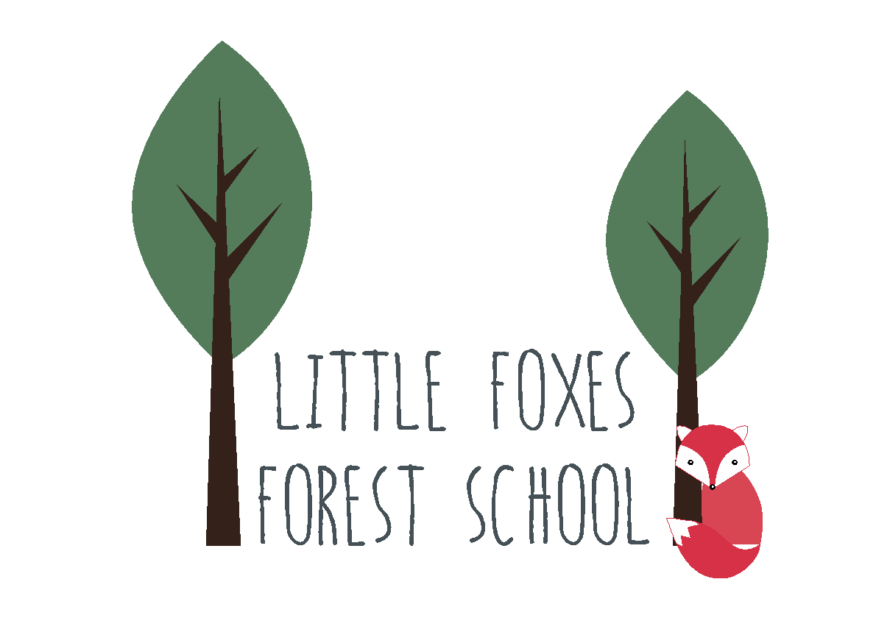
Little Foxes Forest School Spring Tea Club Term Menu 2026

Dates | First course | Pudding
Week 1: 5th January, 26th January, 23rd February, 16th March | Monday: Veggie pasta bake | Satsumas
 | Tuesday: Cream cheese and cucumber wraps served with crudites | Apples and yoghurt
 | Wednesday: Cheese on toast | Organix gingerbread
 | Thursday: Children to help prepare fruit or vegetables for afternoon snack.
Week 2: 12th January, 2nd February, 2nd March, 23rd March | Monday: Beans on Toast | Pear and yoghurt
 | Tuesday: Tomato soup served with cheese toasties | Apple rice cakes
 | Wednesday: Mozzarella and tomato tart served with salad vegetables | Honeydew melon
 | Thursday: Children to help prepare fruit or vegetables for afternoon snack.
Week 3: 19th January, 9th February, 9th March, 30th March | Monday: Veggie sausages, mash and peas | Apple crisps
 | Tuesday: Snack plate with cheese pastries, buttered crackers, veggie sticks, yogurt dip | Pineapple and strawberries
 | Wednesday: Marmite and cheese sandwiches served with crudites | Bananas and yoghurt
 | Thursday: Children to help prepare fruit or vegetables for afternoon snack.

