Existing Injuries Form
Child’s Name: |  |  |  |  |  |  |  | Date of Birth:
Reported to setting by: |  | Parent Other childcare setting Other
Date and time injury occurred:
Place injury occurred:
Name of witnesses/adults present:
Description of how the injury occurred:

Description of the injury: |  |  |  |  | 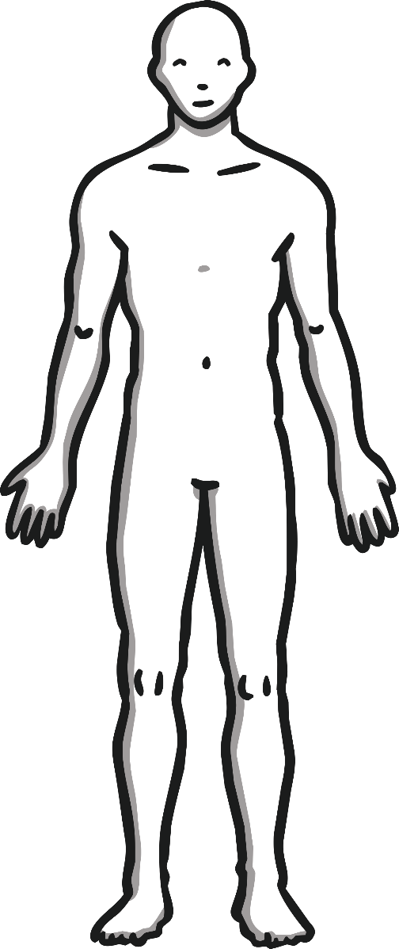
Condition of child following the injury:

Medical treatment or advice sought: Yes No
If yes, please describe below:

Other comments:

Practitioners notified of existing injury at the start of the session: Yes No
Practitioners notified of existing injury during the session: Yes No
Was this injury noticed during the session? Yes No
If yes, please describe how the injury was found, why it is believed it is in fact an existing injury and that it has not occurred at the setting.

Attending adult’s signature: |  |  |  |  |  |  |  |  | Date:
Leader’s signature: |  |  |  |  |  |  |  |  | Date:
Parent's signature: |  |  |  |  |  |  |  |  | Date:
Parent Copy |  |  |  |  |  |  | Paper |  |  |  | Email

Existing Injury Guidance

If a child arrives at the setting with an existing injury parents/carers must inform staff on their arrival and will be asked to complete an ‘Existing Injury’ form, detailing how the injury occurred.

If a mobile child arrives with an injury, we will:
- Request that the parent/carer completes an existing injury form;
- Once complete, the parent/carer and worker should sign the form
- If not reported by the parent/carer, the child’s key worker should complete the form.
- Inform the child’s parent/carer when they arrive to collect the child that a form has been completed and request they sign the existing injury form.
- Remind them of the settings procedure to inform staff of existing injuries including an explanation of how it occurred.

Concerns
If any staff member is concerned about any existing injury and/or the explanation given, they will refer to the setting’s Child Protection Policy.

